Ch 6 Demand Side Interventions

Introduction
As successive years of low rainfall accumulated, Cape Town gradually, and then abruptly, attempted to adapt to the reality of water as a scarce resource.
Some adjustments were introduced and enforced through government, for instance increases water restrictions and tariff adjustments, while others arose organically through the local and international responses to the risk of water shortages or cut off.
These adaptations are discussed below.

Water Restrictions
- Water restrictions are common feature of water management in Cape Town from before the recent drought, with level 1 restrictions in place since 2005, through until January 2016, escalating to the current level 6B that is in place as of Feb 2018.
- Restrictions range from level 1, in which guidance was provided as to preferred hours to water gardens, through to level 6B, in which households are restricted to a maximum of 50l per person per day, enforced through stiff financial penalties and threats of water being forcibly restricted.
- Non-residential groups such as commercial businesses, educational facilities and agriculture, though late to be included in the restrictions, were not spared, with level 5 and 6 restrictions requiring them to cut water consumption by up to 60% compared with pre-drought levels.
- While restrictions initially yielded strong results in reducing demand, with the city reporting between 10% and 15.5% reductions in consumption from initial level 1 and 2 restrictions, the impact of subsequent restrictions has been difficult to quantify due to them happening concurrent to a variety of other mechanisms in place to reduce demand.
- When considering the pace of updates to water restrictions, with some steps in place for only a single month before a new rule being rolled out, it is worth considering how this may impact on households and businesses ability to keep track of and adapt to the changes in rules. The notion of “compliance” with restrictions could easily have become a confusing one even for those with full intention to adhere to rules, with targets shifting from 100l to 87l to 50l per person per day within 6 months, to PR campaigns requesting households to aim for 10500l per month, then 6500l per month, then 4500l per month becoming the maximum allowed before fines would be applied. There was also ambiguity around to what extent the restrictions should be applicable to those not drawing water from the municipal supply chain.
- Overall, a more structured approach, e.g. quarterly reviews, may have made it easier for households to digest and adapt to the restrictions.

Water restriction level | Date applied | Period active | Description
1 | 2005 | 11 years | Level 1 focused on reducing non-essential water use by providing guidance on hours for watering gardens (ref: news article level 1 restrictions) and produced a 15.5% reduction in water consumption (ref: level 3 FAQs)
2 | Jan 2016 | 11 months | Level 2 increased garden watering restrictions to specific days of week and maximum time, and focused on reducing the use of hosepipes unless having an auto stopper fitted (ref: city publication level 2 restrictions) and produced a 10% savings (ref level 3 FAQs)
3 | Nov 2016 | 3 months | Level 3 added restriction on HOW watering could take place, only allowed with a bucket or watering can, no use of hosepipes or irrigation systems. Cars and boats to be washed from buckets. Swimming pools to be fitted with a pool cover. No portable play pools are to be used. (ref level 3 FAQs)
3B | Feb 2017 | 4 months | Level 3B restrictions - further restricted days/times of watering allowed to 2 days a week, no watering sportsfields allowed at all, no watering within 48 hrs rainfall (ref: level 3b city of cape town doc)
4 | June 2017 | 1 month | Level 4 limited people to “suggested” max 100l per person per day, and banned all “non-essential”municipal water use, e.g. all gardening, pools (ref city publication level 4 restriction)
4B | July 2017 | 2 months | Level 4B restrictions limit to 87l per person and advised that Water Management Devices would be fitted to errant properties (ref: webpage 4b restrictions)
5 | Sep 2017 | 4 months | Level 5 restrictions, primary change to introduce targets for commercial properties to reduce consumption by 20% compared with 2016, and agriculture by 30% (ref: city of cape town publication level 5 restriction)
6 | Jan 2018 | 1 month | Level 6 restrictions, increased commercial limits to 45% / agriculture to 60%
6B | Feb 2018 | 5 months + | (ref: city publication 6b water restrictions) Limited households to a maximum of 50l water per person per day. Applied restrictions to how municipal water can be used (no topping up swimming pools, no watering gardens, no washing cars or outside surfaces). Applied restrictions to businesses (all businesses (including schools, offices, etc) must reduce consumption by 45% compared with 2015, all agriculture must reduce consumption by 60% compared with 2015)

Punitive/financial measures (fines/tariff increases)
  - Cape Town water operates on a step tariff with water becoming relatively more expensive as more is used, and different tariff rates applicable depending on the level of water restrictions in place. Sanitation charged as a percentage of water consumption tariff.
  - Tariff increases on higher-consumptions steps in an effort to reduce high water consumption.
  - Prior to drought crisis, all households receive the first 6kl of water per month free, while indigent households received an additional 4.5kl free. Beyond that quantity, all households, indigent and non-indigent alike, are charged the same tariff.
  - The city is limited to an annual adjustment of tariffs as part of their budget review, comes into effect in July, but also applied pecuniary penalties through fines for transgressive behaviour and high-consumption households.
  - In the 2017/2018 budget, the free allocation of 6kl of water for all households that had been in place was removed for non-indigent households.
  - June 2018 - new bylaw passed to add a fixed monthly connection charge irrespective of consumption, based on the size of the meter connection
  - The city faces contradictory incentives in relation to water demand, in that reducing the consumption represents a loss of income, acutely so for those households consuming in higher tariff steps.

Step | Level 1 restriction @ July 2016 effective rate per kl | Level 4 restriction @ July 2017 effective rate per kl | Level 6 restriction @ July 2018 effective rate per kl
1 (0kl < 6kl pm) | 0 | R4.56 * | R33.24*
2 (6kl < 10.5kl pm) | R14.89 | R17.75 | R52.90*
3 (10.5kl < 20kl pm) | R17.41 | R25.97 | R138.31
4 (20kl < 35kl pm) | R25.80 | R43.69 | R138.31
5 (35kl < 50kl pm) | R31.86 | R113.99 | R1,150.00
6 (>60kl pm) | R42.03 | R302.24 | R1,150.00
Connection fee | n/a | n/a | R64.40

*Free for indigent households
NB - all values inclusive of VAT

  - July 2016 water tariff charges (applicable level 1 restrictions, single dwelling residential properties)
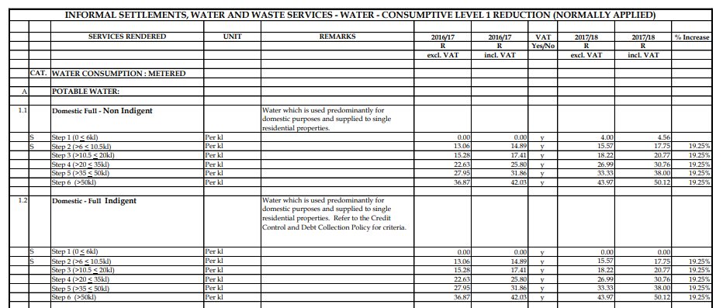
  - July 2017 water tariff charges (level 4b restrictions in place)
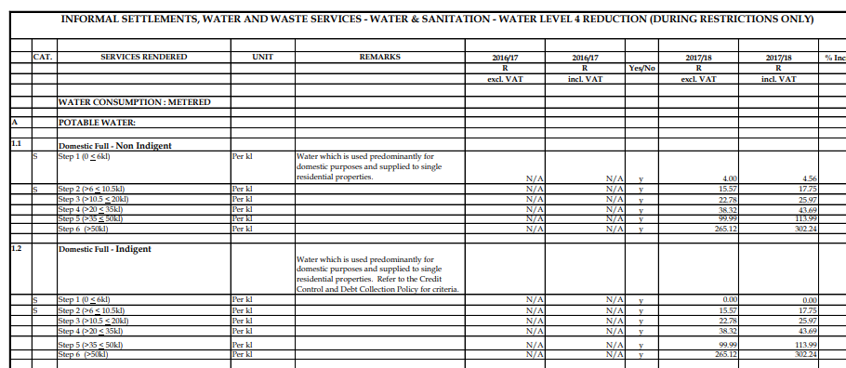
- July 2018 (level 6B restrictions in place)
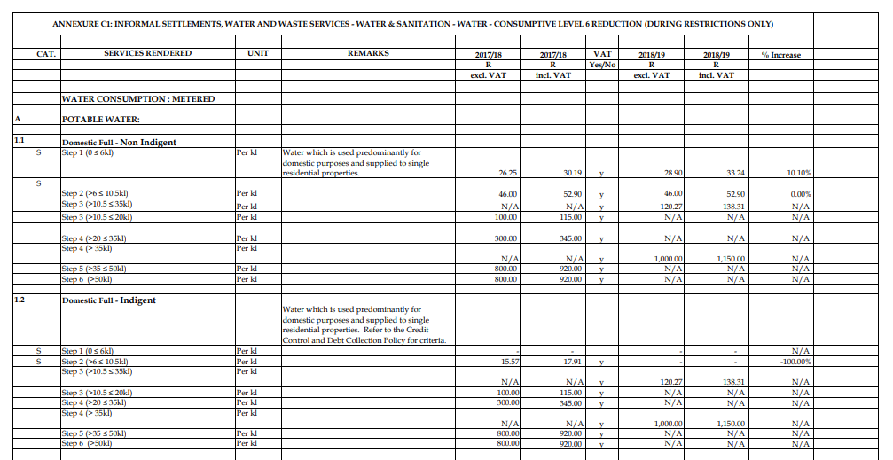

Enforced reductions in water consumption
Aside from attempts to motivate citizens to voluntarily reducing consumption via tariff changes and restrictions, the city also worked on water demand reduction initiatives that did not rely upon cooperation or voluntary reductions. Specifically, they accelerated the roll out of water management devices, and pressure reductions. Each of these are discussed in turn below.

Water Management Devices
(ref: water management devices city of cape town website, plus WMD pdf by city of CT)
- Water Management Device (or WMD) is equipment that is installed to a water supply pipe that is set up to allocate and enforce a set daily limit of water for a property. After the maximum withdrawal is reached for the day, the water is reduced to a trickle until the following day when service is resumed.
- WMDs were initially rolled out by the city prior to the drought, targeting indigent households. It was a voluntary program that households could choose to sign up for, and was billed as a way for them to save money by capping their consumption at their maximum free allocation, and prevent excessive water loss through leakages.
  - Indigent definition as per National Framework: “Lacking the necessities of life”. (ref national framework on indigent households)
  - City of Cape Town allows people to apply for indigent status based on their monthly income - if between R4000 and R6000 per month, they receive free or discounted rates on municipal services. (ref city of cape town indigent website)
  - City incentivised indigent households to take up the device by offering a free once off house leakage fix, and a write off of historic water debt, and would install the device free of charge.
  - WMDs as standard are set to restrict households to 350l per day, or 10.5l per month. Households that require more, for instance because of having additional residents, must apply to the city for increased allocation.
  - As part of level 4 restrictions being introduced, the strategy of installations of WMDs shifted to focus on high consumption households who refused to voluntarily reduce consumption following warning letters.
    - All households with consumption above 10.5kl per month were potentially eligible to have a WMD fitted
    - Around 3500 devices installed per week
    - Aside from forcibly reducing consumption, the household would also be charged for the device and installation through their monthly utility bill
  - As at March 2018, 250,000 WMDs installed in Cape Town. (ref: Groundup article), but the majority of these relate to the indigent program of installation. 13,290 related to high-consumption households.
  - While effective at enforcing a reduction in water consumption, many negative impacts were observed
    - Question raised around the equity of fitting the devices
      - perception that houses with poor payment records were being prioritised for installation ahead of those with equally high consumption but who were continuing to pay, as the city was wanted to maintain their income.
    - Question around daily allocation accuracy (many households, particularly in less-wealthy suburbs, have more than 4 people living in the house as per the 350l pd allocation - onerous process to apply to have limit increased)
    - Malfunctioning devices (no official stats published around devices malfunctioning, but many complaints from people)
    - Hostility from residents - initially used as a “name and shame” publicity tool whereby the mayor was filmed on site at high consumption households helping install the devices, became standard for police to accompany installation team to prevent violence towards them
    - Broken lines of communication - WMD installed by contractors, difficult for residents to report and have devices fixed timeously.
    - Question around long term value of devices - they are not the same as a Smart Water Meter, they only restrict the consumption as per set daily value. Still require manual meter readings for billing. When daily restrictions no longer in place, they will not provide value for wealthier households that would otherwise be willing to consume/pay higher rate to consume more.

Publicity around day zero/water collection points
  - Announcement used as a tool to galvanise action in the public
  - Week following announcement
    - Panic behaviour
      - Shopping
    - Drop in water consumption
    - Anger from citizens

Social and behavioural impacts

Behaviour change in households
- Change in household water usage behaviour (shower in buckets, reuse grey water, etc.)
  - As part of water restrictions from phase 3 onwards, the city began publishing recommended behaviours for reducing household water consumption (ref city of cape town water saving tips publication)
    - Only flush the toilet “when necessary” e.g. not after urinating
    - When necessary to flush, only flush toilet with grey water
    - Wash hands with waterless hand sanitiser, wash fruit/veg with waterless food sanitiser
    - Take “stop-start” showers - e.g. turn on water to wet yourself, turn off water, then soap yourself up, then turn on water to wash off soap.
    - Shower above a bucket and catch the water to use to flush toilet
    - Catch rainwater in rainwater tanks/buckets
Excerpt images from CoCT publication “Water Saving Checklist to Avoid Day Zero”
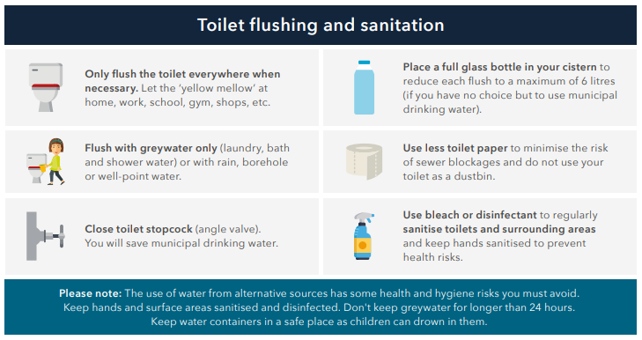
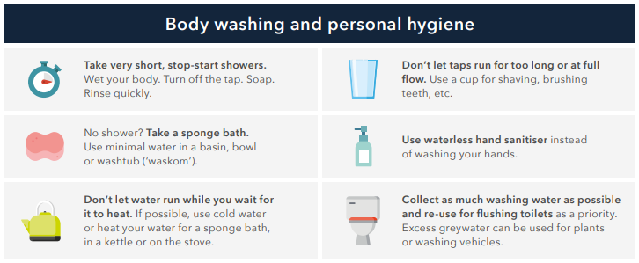
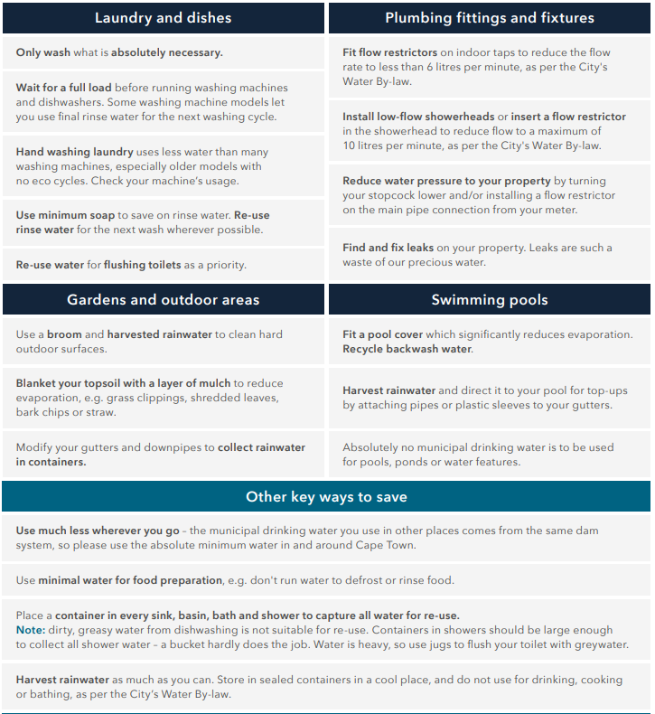

  - Many of these behaviours were adopted by residents and became social norms in many communities
    - Reduced stigma around not flushing toilet at restaurant/office bathrooms (some places introduced “permission” toilet stalls for this)
    - Commonplace for houses not to have their toilet cisterns disabled and a bucket of greywater available for guests to flush

- Blame/shame of heavy water users
  - City’s tone of messages has ranged from “blaming
  - Due to widespread adoption of suggested behaviours, transgressors increasingly shamed by community and city (ref: CoCT press release CCT day zero now likely to happen)
    - “It is quite unbelievable that a majority of people do not seem to care and are sending all of us headlong towards Day Zero.” Mayor de Lille
    - City encouraged reporting people not following restrictions e.g. watering gardens/topping up swimming pools etc. by providing toll-free hotlines
    - City published list of the roads in which the top 100 water consumers live, naming them as “water guzzlers” (ref: CCT 121 days left)

- Creation of community groups centred around water crisis information/assistance
  - Enlisted neighborhood watches as connection point to communities for day zero collection points, to identify vulnerable community members requiring help
  - Facebook groups - watershedders cape town

Extreme pressure reductions
  - The city has undergone a process of reducing the pressure in municipal pipes by dividing city into zones associated with pumping stations, and reducing pressure at the pumps.
  - This reduces the amount of water lost through leaks, as well as the amount that is consumed within time-based water consuming household activities (e.g. shower, washing hands, etc.)
  - City has identified it as saving 50 million litres per day during the drought
  - Negatives:
    - Did lead to water outages in some high lying areas and apartment blocks where separate pumps/rooftop storage weren’t in place
    - Research has shown that frequent variations in pressure damages infrastructure (ref: pressure reduction article)

Smart water meters
    - Voluntary adoption of smart water meters has been limited, and not directly encouraged by the city
    - Smart water meter campaign was run to target schools
      - Roll out more than 300 SWM in schools across Cape Town, starting from low income high consumption schools
      - Run in conjunction with a behaviour change campaign
      - Funded through partnership between Western Cape Government and private organisation
      - Saving over 670,000l water per day through identification of leaks (based on night flow consumption) and behaviour change
    - Potential to maximise impact through scholars as agents, taking lessons on water savings home

Mobile apps to record consumption
    - Free and paid mobile apps available to help people manage their water consumption and provide access to water related information
    - Drop Drop
      - Developed as research prototype by UCT
      - Free to use
      - Provides households with information about water savings and a tool for them to use to log and track their water consumption, and see predictions for their bill and expected consumption for the month
      - 1000+ users

Nudging for water
  - Water bills used to nudge for reductions
    - 400,000 households randomly allocated to 8 treatment groups or control
    - Received an insert in their bill every month for 6 months aligned with a particular economic framing to encourage water savings (financial savings, financial loss, social recognition, shared public goods, etc.)
    - Analysis found that all nudges effective at savings (around 2% savings), but different impacts between households of different economic status
    - High income households most affected by social recognition and comparison treatments
    - Low income households more affected by financial framing
    - Perverse impact on behaviour of indigent households, with increased consumption seen
    - Impact on behaviour lasted over 18 months beyond the nudges being sent
    - Cost effective with minimal negatives method to reduce consumption compared with augmentation methods and tariff increases
  - Letters to high consumption households
    - <analysis of data is ongoing>

Increasing transparency of existing water usage data
Relevant link for tracking of usage from resource.capetown.gov.za:
- Cape Town water map
  - Website developed by the city which shows representation of compliance with water restrictions per household
  - Conceptualised as a social recognition tool
  - Very mixed response from the public, houses not shown to be compliant were shamed
  - Design didn’t accommodate include a control group, so unable to determine net impact on water consumption

